**FLOW CHART**

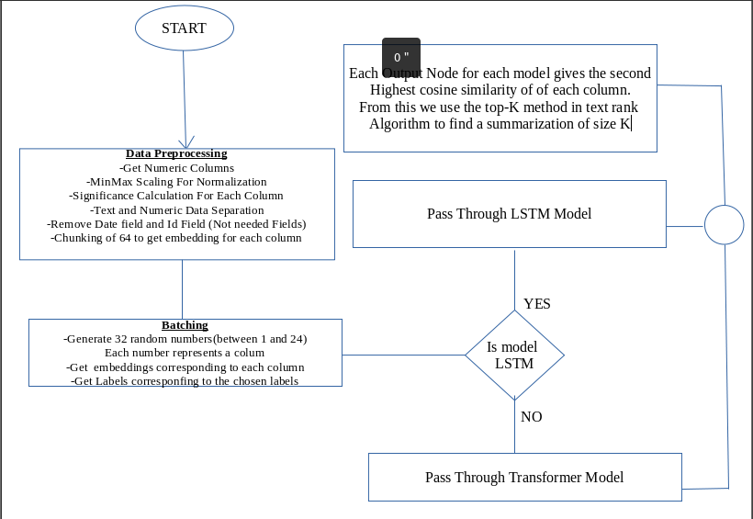

**3.1.1: Data Source**

In the pursuit of unraveling the intricate tapestry of weather data for our research on weather data summarization, a pivotal aspect of our journey involved the acquisition of diverse and comprehensive datasets. Our primary source for this wealth of atmospheric information was the esteemed WorldWeatherOnline.com, a platform renowned for providing detailed and accurate weather data.

**3.1.2: Data Cleaning and transformation**

The journey from raw weather data to a refined, model-ready dataset involved a meticulous process of data preprocessing, separation, scaling, and label generation. This section unveils the intricacies of these preparatory steps, highlighting the decisions and methodologies that laid the groundwork for our subsequent model training endeavors. Upon harvesting data from WorldWeatherOnline.com, the initial challenge lay in dealing with a dataset that amalgamated numerical and textual information. To tackle this, we initiated a segregation process, isolating numerical columns from their textual counterparts. This segregation laid the foundation for focused preprocessing, ensuring that the distinct nature of numerical and text data could be catered to separately.

Uniformity in scale is imperative when dealing with numerical data, especially in the context of neural network embeddings. Leveraging the MinMax scaling technique, we normalized the numerical data, bringing all columns to a common scale. This not only facilitated convergence during training but also ensured that each feature contributed proportionally to the model's understanding, preventing dominance by any specific parameter. To capture temporal patterns within the weather data, we adopted an embedding strategy. Slicing the numerical data into chunks of 64, we created embeddings representing the temporal evolution of each column. This embedding approach encapsulated the dynamics of weather parameters over specific time intervals, fostering a more nuanced understanding of temporal trends.

The end result of this intricate label generation process was a vector of length 24, each element representing the second-highest cosine similarity value for a specific column. These labels became the blueprint for training our neural network model. By encapsulating the relational dynamics between weather parameters, the labels enabled the model to discern subtle patterns and interdependencies, enriching its capacity for weather data summarization.

**3.2: Summarization Model Development**

The proposed neural architecture for weather data summarization employs two distinct models, Long Short-Term Memory (LSTM) and Transformer, operating independently. The rationale behind this approach is to leverage the unique strengths of each model and subsequently compare their performances in distilling meaningful insights from the high-frequency weather dataset comprising 24 diverse parameters observed over 1464 hours. The LSTM model is tasked with capturing short-term variations within the weather data. Its recurrent nature allows it to retain information over sequential data points, enabling the model to understand temporal dependencies and nuances within the hourly observations. The LSTM processes the daily embeddings created by concatenating 64 consecutive hourly readings, providing a comprehensive representation of short-term variations in the weather conditions.  
On the other hand, the Transformer model, renowned for its attention mechanisms, is adept at capturing long-range dependencies and contextual relationships within sequences. In our architecture, the Transformer processes the same daily embeddings, focusing on the temporal dynamics and complex inter-dependencies inherent in the weather data. The attention mechanisms enable the model to weigh the importance of different timestamps and parameters, enhancing its ability to discern patterns over extended periods.

The output from both the LSTM and Transformer models is then passed through a Multilayer Perceptron (MLP) with 24 output neurons, each employing a hyperbolic tangent (tanh) activation function. The objective is to create a unified framework for the subsequent stages of the model. The final step involves using a Mean Squared Error (MSE) loss function to optimize the model's parameters by minimizing the difference between the predicted and actual cosine similarity values. Cosine similarity is computed by measuring the similarity between the embeddings of each parameter, providing a quantitative measure of how closely related they are in the context of weather conditions. The highest cosine similarity for each day is assigned to the corresponding output neuron, following the concept of the TextRank algorithm. This algorithm, adapted for the weather data summarization task, ranks the significance of each parameter for a given day, contributing to the overall understanding of the atmospheric conditions.

In essence, the proposed neural architecture utilizes LSTM and Transformer models independently, each contributing unique perspectives to the summarization task. The comparative analysis of their performances sheds light on their respective strengths and weaknesses, ultimately providing insights into the most effective model for distilling meaningful information from the complex, high-frequency weather dataset.

**3.2.1: Selection of Algorithm**

The selection of neural network architectures is a critical decision that significantly shapes the trajectory and efficacy of any machine learning project. In the realm of weather data summarization, where temporal dependencies and contextual understanding are paramount, the choice of models becomes especially pivotal. This section provides a comprehensive rationale for the strategic selection of Long Short-Term Memory (LSTM) and Transformer architectures as the bedrock of our weather data summarization framework.

**3.2.1.1: LSTM Model**

LSTM, a specialized type of recurrent neural network (RNN), possesses inherent strengths in capturing temporal dynamics and sequential dependencies within data. Weather data is inherently temporal, with patterns and trends evolving over time. The LSTM architecture, equipped with memory cells that selectively retain and discard information, excels in preserving long-term dependencies. This capability aligns seamlessly with the nature of weather data, allowing the model to discern patterns and trends that extend across multiple time steps.

The memory mechanism in LSTM serves as a powerful tool for embedding complex relationships within sequential data. Weather parameters often exhibit intricate dependencies, where the state of one parameter at a given time influences and is influenced by the states of others. LSTM's memory cells act as repositories for such dependencies, enabling the model to learn and recall contextual information crucial for accurate summarization. This capacity to capture inter-parameter relationships is pivotal in distilling meaningful insights from the rich tapestry of weather data.

**3.2.1.2: Transformer Model**

While LSTM excels in sequential modeling, Transformers introduce a paradigm shift with their parallel processing capabilities and attention mechanisms. Weather data, characterized by multiple parameters evolving concurrently, benefits from the parallelization inherent in Transformer architectures. The attention mechanism allows the model to focus on specific elements of the input sequence, enabling it to weigh the importance of different parameters dynamically. In the context of weather data summarization, this attention mechanism becomes invaluable for prioritizing and synthesizing information effectively.

Transformers are renowned for their ability to capture global context within a sequence, making them well-suited for scenarios where understanding the relationships between distant elements is crucial. In weather data, where parameters across different time steps may influence each other, this global context awareness becomes pivotal. Transformers facilitate the modeling of complex interactions across the entire temporal span, providing a holistic view that complements the localized dependencies captured by LSTM.

**3.2.2: Algorithm Configuration**

The successful training of neural networks hinges not only on the architectural choices but also on the careful selection of hyperparameters. In our weather data summarization endeavor, where the interplay of parameters and temporal dynamics demands a delicate balance, the choice of hyperparameters becomes a pivotal aspect of model training. Here, we delve into the rationale behind our specific choices of learning rate, batch size, and embedding size, elucidating how these decisions contribute to the effectiveness of our neural network framework.

The learning rate serves as a guiding force for the optimization process, determining the step size in the vast landscape of model parameter updates. In our weather data summarization framework, a learning rate of 1e-5 was chosen deliberately. This relatively low learning rate fosters a gradual convergence, preventing overshooting and oscillations in the optimization trajectory. Given the intricacies of weather data and the need for nuanced adjustments in the neural network weights, a conservative learning rate aligns with the goal of steady and precise model updates.

The batch size, representing the number of data points processed in each iteration, strikes a delicate balance between computational efficiency and model generalization. In our framework, a batch size of 32 was chosen. This intermediate size ensures that the model processes enough data to gain meaningful insights in each iteration while maintaining computational efficiency. Larger batch sizes could lead to increased computational demands, potentially hindering the model's generalization capacity. A batch size of 32 strikes a pragmatic equilibrium, allowing the model to learn from diverse samples without compromising on computational efficiency.

The interplay of learning rate, batch size, and embedding size reflects a harmonious orchestration of hyperparameters tailored to the unique demands of weather data summarization. The conservative learning rate fosters precision in model updates, the moderate batch size balances computational efficiency and generalization, and the carefully chosen embedding size captures the temporal intricacies of weather dynamics. This synergy ensures that our neural network navigates the vast neural tapestry with finesse, distilling meaningful insights from the complex and dynamic atmospheric data.

**3.3: Experiment Design**

**3.3.1: Factors and levels**

**3.3.1.1: Factor 1-Architectural Foundation**

The choice of neural network models constitutes the primary factor in our experimental design. Two architectural powerhouses, Long Short-Term Memory (LSTM) and Transformer, serve as the focal points of our investigation. Each model encapsulates unique strengths, with LSTM excelling in capturing sequential dependencies and Transformer bringing parallel processing and global context awareness to the forefront. The exploration of these models as distinct factors aims to unravel their individual contributions to the summarization process.

Within the factor of neural network models, we navigate the intricate landscape of architectural nuances by considering two distinct levels: LSTM and Transformer. LSTM, with its sequential modeling prowess, is poised to capture temporal intricacies within weather data. On the other hand, Transformer, with its parallel processing and attention mechanisms, offers a holistic view of parameter dependencies. The exploration of these levels unveils how the architectural choices influence the models' abilities to distill insights from the dynamic and multifaceted weather data.

**3.3.1.2: Factor 2-Model Training Approaches**

Beyond the architectural distinctions, the second factor encompasses different approaches to model training. This factor acknowledges the influence of training strategies on the convergence and generalization of the models. The exploration involves variations in training hyperparameters, initialization methods, and optimization algorithms, shedding light on the methodological choices that underpin the successful deployment of LSTM and Transformer in the weather data summarization task.

Within the factor of model training approaches, we traverse the methodological landscape by considering various levels. These include distinct combinations of hyperparameters such as learning rates, batch sizes, and initialization strategies. The exploration aims to unravel how these methodological choices impact the training dynamics, convergence speed, and overall performance of LSTM and Transformer. By scrutinizing different levels within this factor, we gain insights into the robustness and adaptability of our models across diverse training scenarios.

**3.3.2: Experiment Setup**

Embarking on the intricate journey of weather data summarization necessitates a robust experimental setup that leverages cutting-edge tools and technologies. In our quest for insightful model evaluations, we strategically employed Google Colab, harnessed the computational prowess of a T4 GPU with 15 GB VRAM, and seamlessly integrated the PyTorch library. This experiment setup lays the foundation for a dynamic and scalable exploration of neural network models in the realm of atmospheric data analysis.

**3.4: Performance Evaluation**

In the realm of weather data summarization, the efficacy of our neural network models is gauged through a meticulous evaluation process, guided by a set of performance metrics tailored to capture the essence of the complex atmospheric patterns. As we navigate through the vast seas of data-driven insights, we rely on key performance metrics to assess the prowess of our LSTM and Transformer models in distilling meaningful summaries from the intricate tapestry of weather parameters.

**3.4.1: Mean Squared Error**

The Mean Squared Error serves as a compass in our evaluation journey, providing a quantitative measure of the average squared differences between predicted and actual values. In the context of weather data summarization, MSE serves as a reliable indicator of the model's accuracy in capturing the nuances of each parameter across the 64-hour spans. By computing the MSE for each parameter, we gain insights into the precision of our models in forecasting temperature, precipitation, and other vital weather elements.

**3.4.2: Cosine Similarity**

Cosine Similarity emerges as a North Star guiding our evaluation, particularly in the context of comparing the similarity between predicted and actual values. This metric leverages the geometric concept of cosine angles to measure the similarity between vectors, in this case, the vectors representing our model predictions and ground truth values. As we traverse the expansive realm of atmospheric data, Cosine Similarity allows us to gauge how closely our models align with the actual patterns, offering a holistic measure of performance.

**3.4.3: Root Mean Squared Error:**

The Root Mean Squared Error acts as a depth sounder, delving into the magnitude of errors between predicted and actual values while considering their square roots. This metric provides a nuanced understanding of the overall error distribution, shedding light on the model's ability to capture both small-scale fluctuations and significant deviations in weather parameters. RMSE complements the MSE by offering a rooted perspective, allowing us to discern the magnitude of errors across diverse weather elements.

**3.4.4: Comparative Analysis**

The performance metrics are not standalone beacons but work in tandem to facilitate a comprehensive comparative analysis between our LSTM and Transformer models. By juxtaposing the MSE, Cosine Similarity, and RMSE results for both models, we gain a nuanced understanding of their respective strengths and limitations. This comparative lens ensures that our evaluation transcends individual metrics, providing a holistic view of how each model navigates the intricacies of weather data summarization.